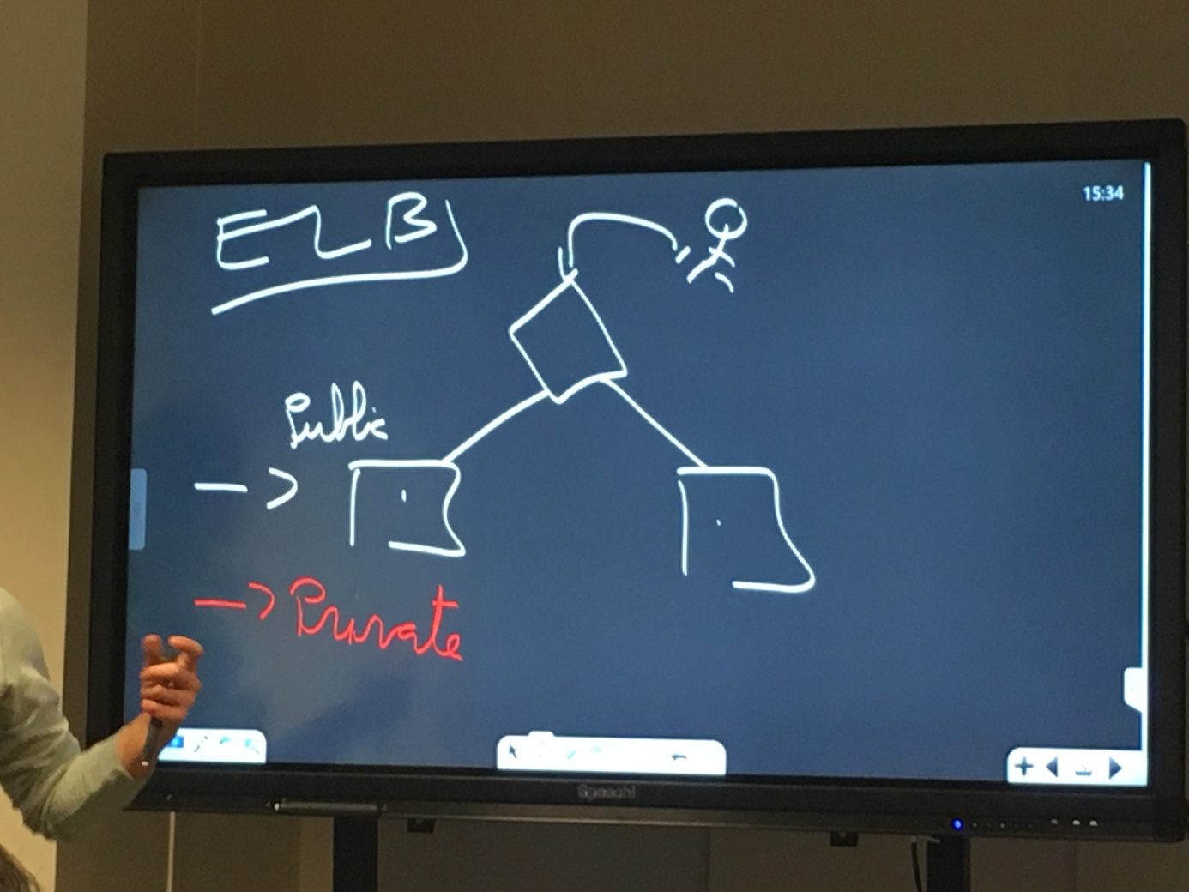

Create a VPC

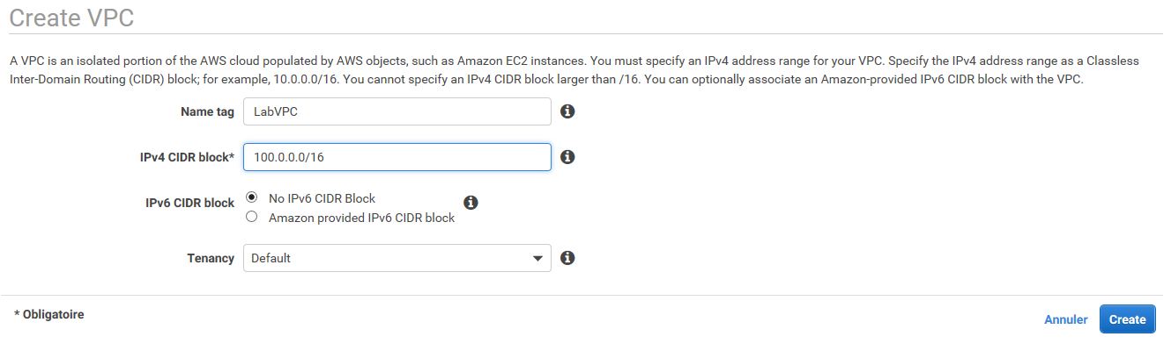

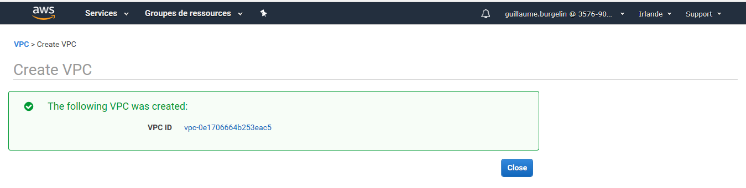

Create Public Subnet 1 100.0.1.0/24 on AZ eu-west-1a

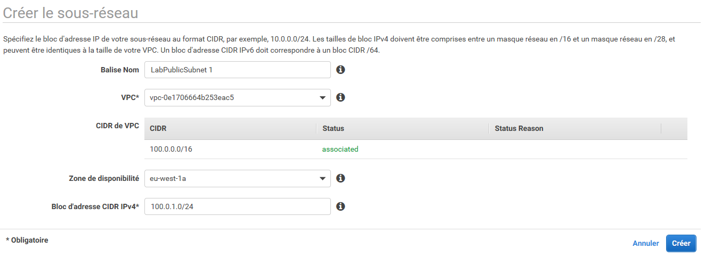

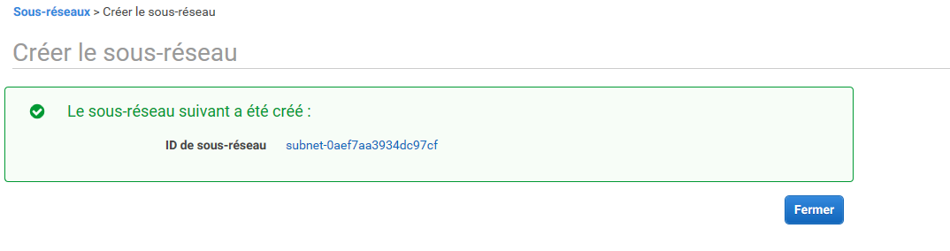

Create Public Subnet 1 100.0.2.0/24 on AZ eu-west-1b

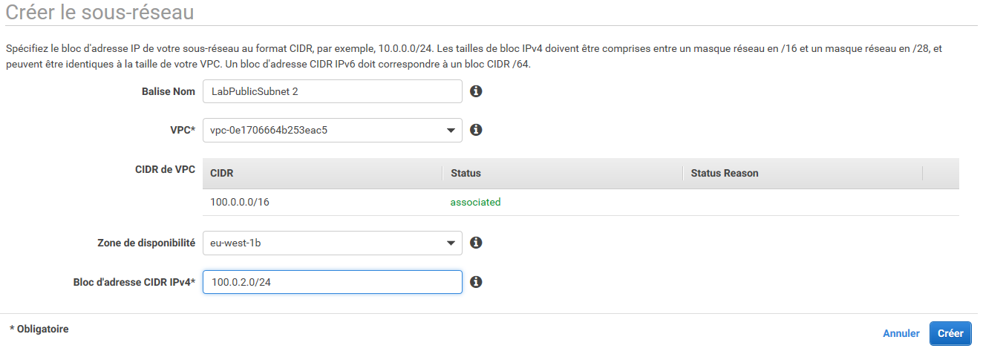

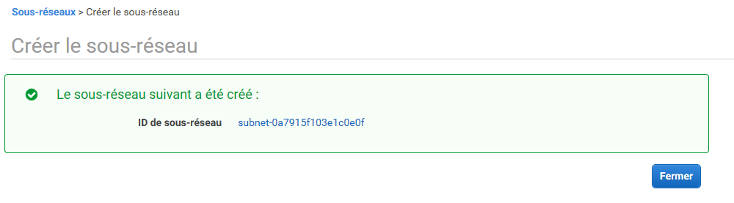

Create a IGw for the VPC

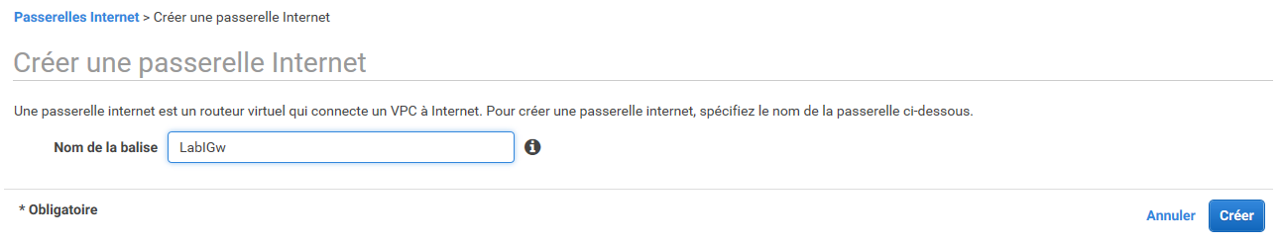

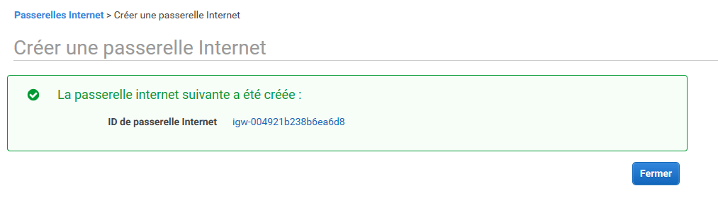

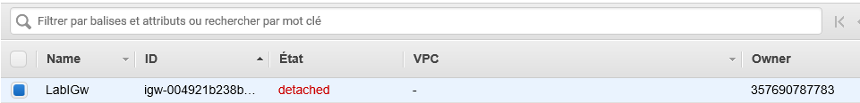

Attach the IGw to the VPC

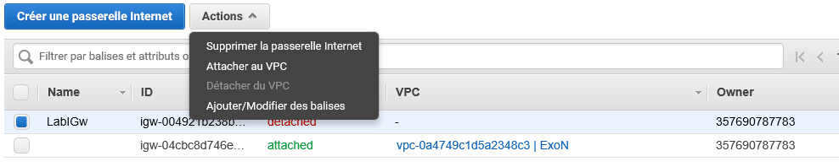

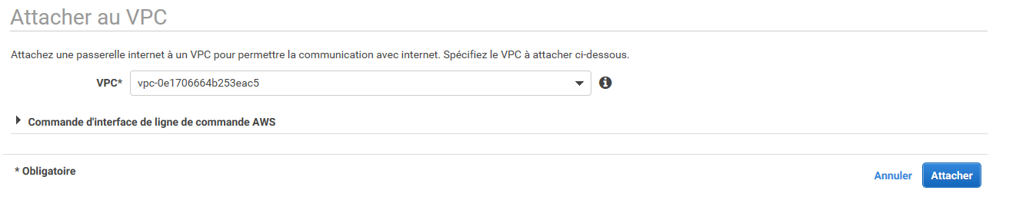

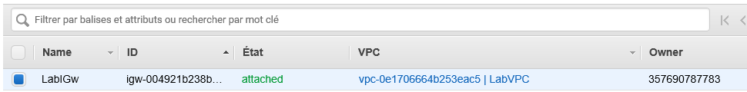

Create a routing table connected to IGw

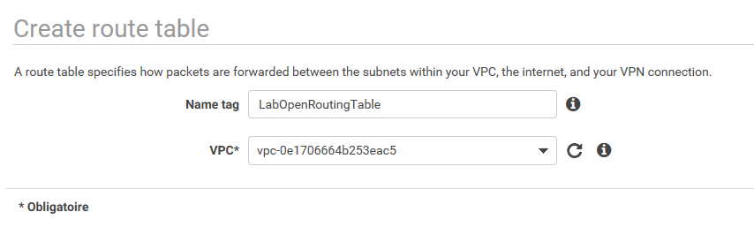

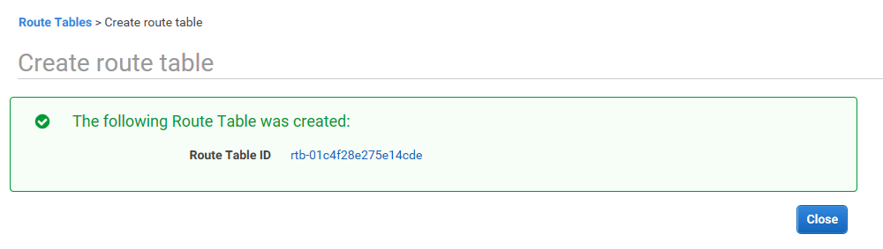

Create a route to the IGw

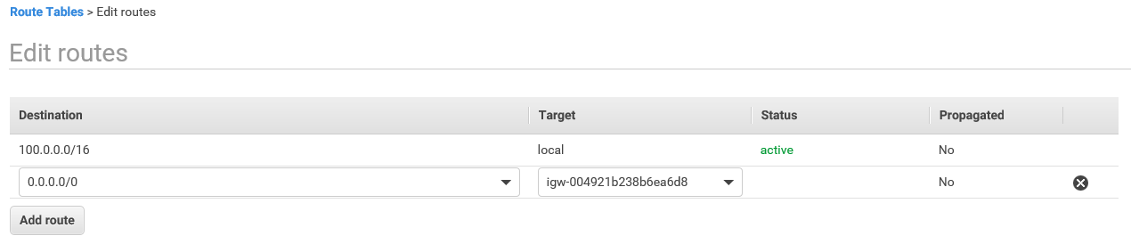

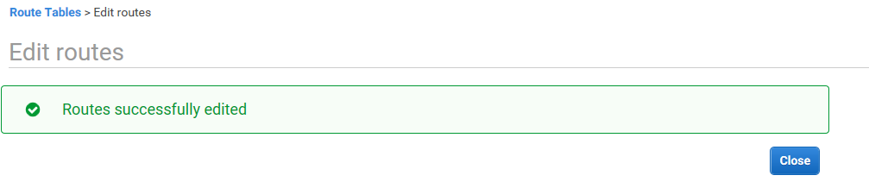

Modify the Subnet Routing table

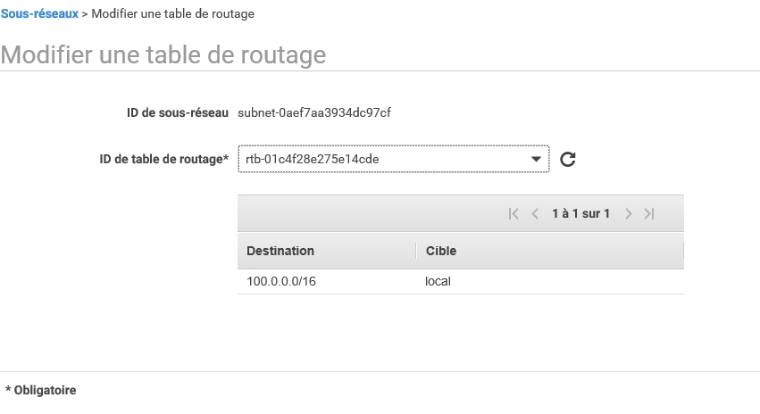

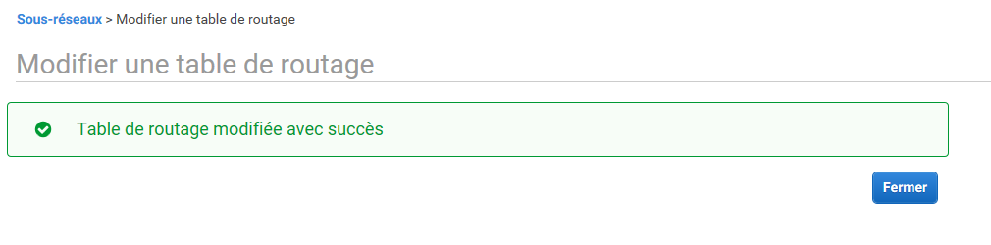

Check the connections of the two public subnets to the IGw

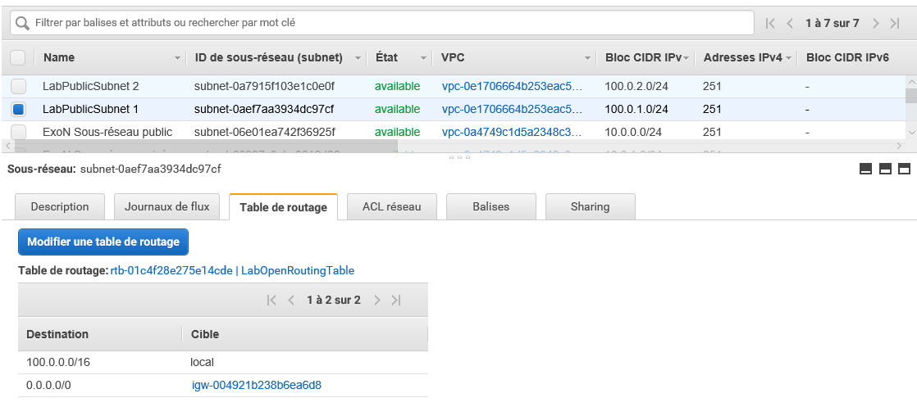

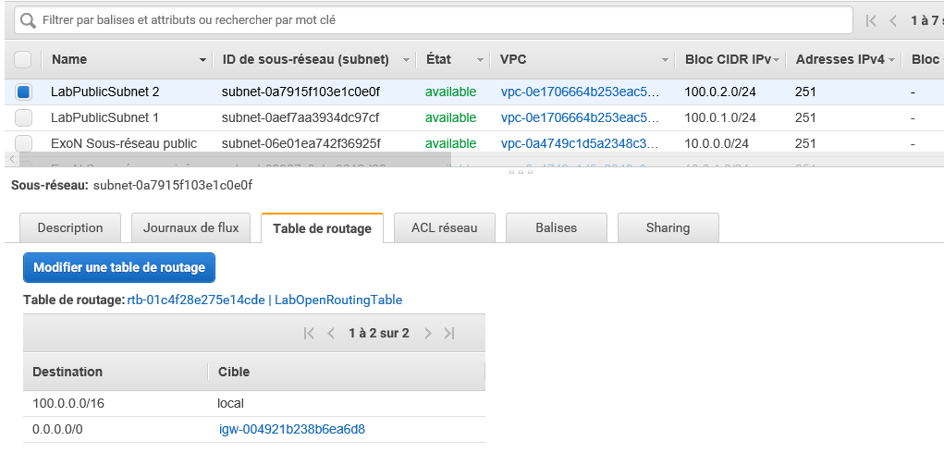

Launch 2 instances : 1 per Public Subnet

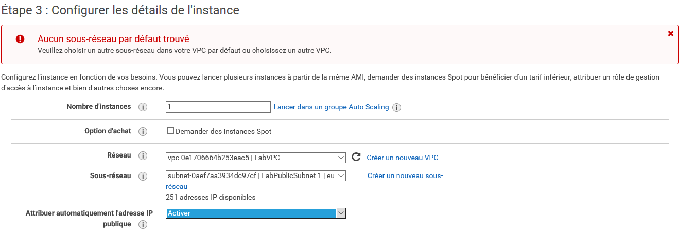

Add the following script to launch (cf Lab2)

#!/bin/bash -ex

yum -y install httpd php mysql php-mysql

chkconfig httpd on

service httpd start

if [ ! -f /var/www/html/lab2-app.tar.gz ]; then

cd /var/www/html

wget https://us-west-2-aws-training.s3.amazonaws.com/awsu-ilt/AWS-100-ESS/v4.2/lab-2-configure-website-datastore/scripts/lab2-app.tar.gz

tar xvfz lab2-app.tar.gz

chown apache:root /var/www/html/rds.conf.php

fi

Create a new Security Group open on Internet

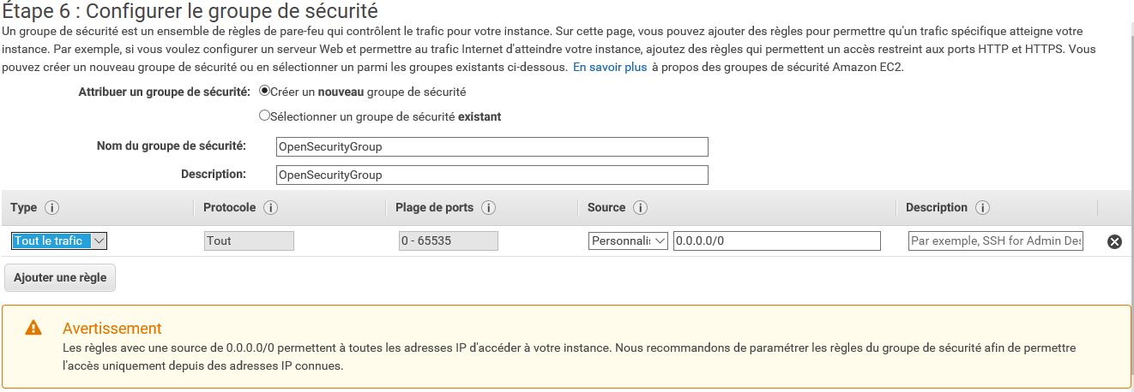

Choose a Key Pair

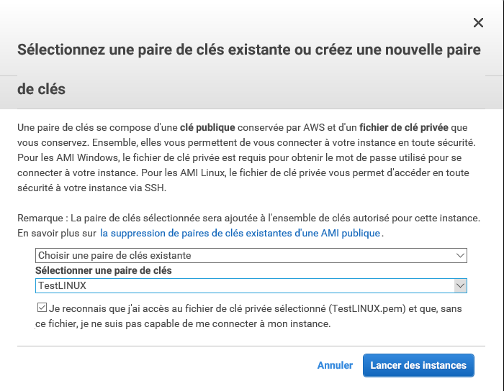

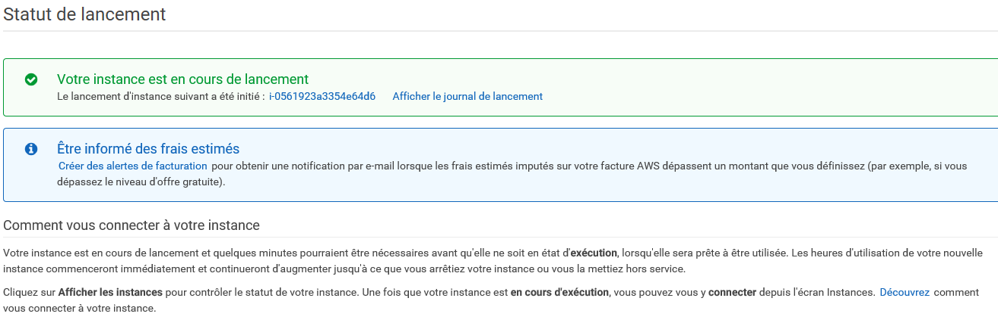

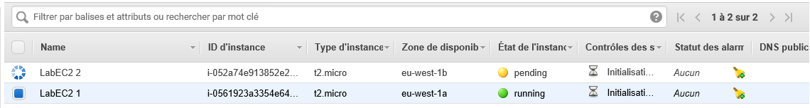

Ping test of the two EC2 :

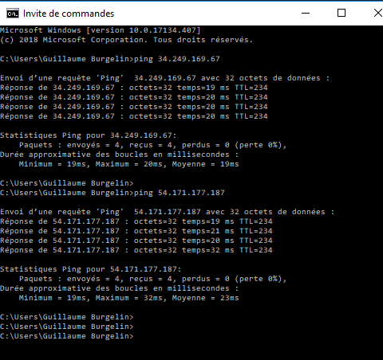

Create a New ELB between the 2 public subnets

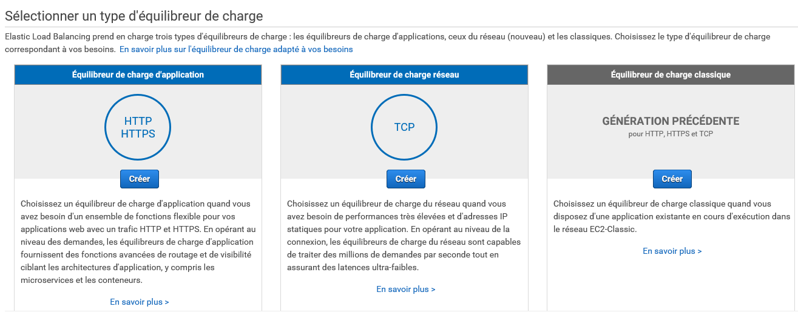

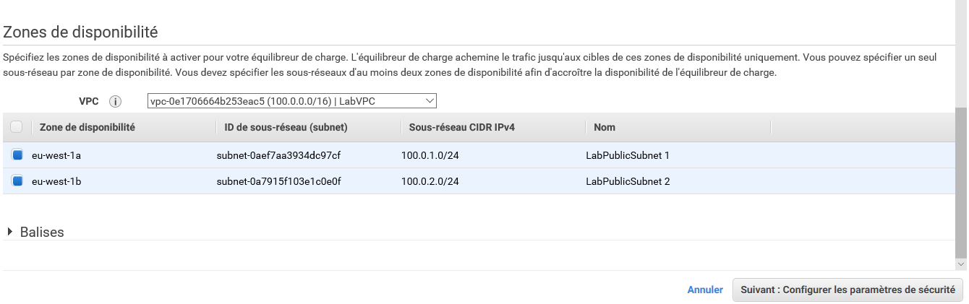

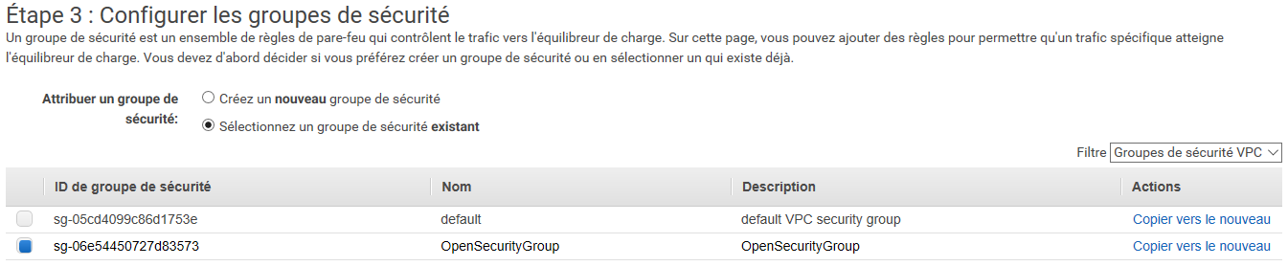

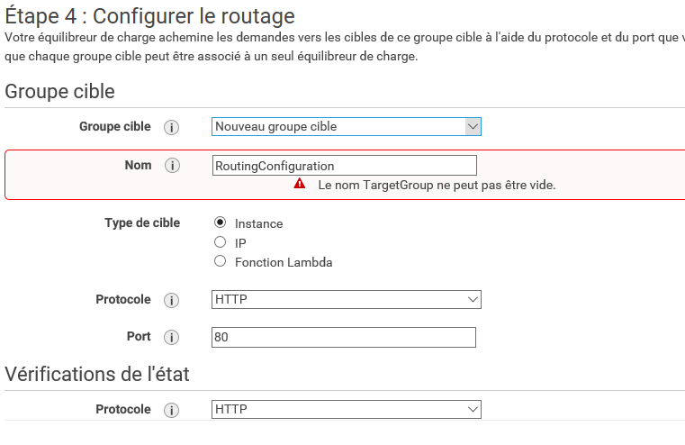

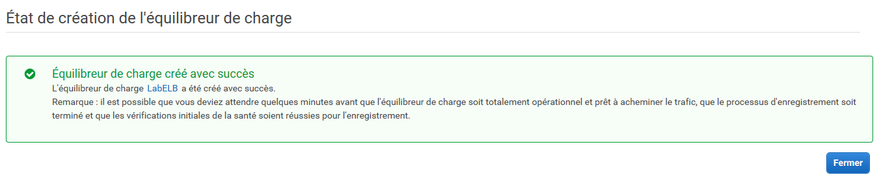

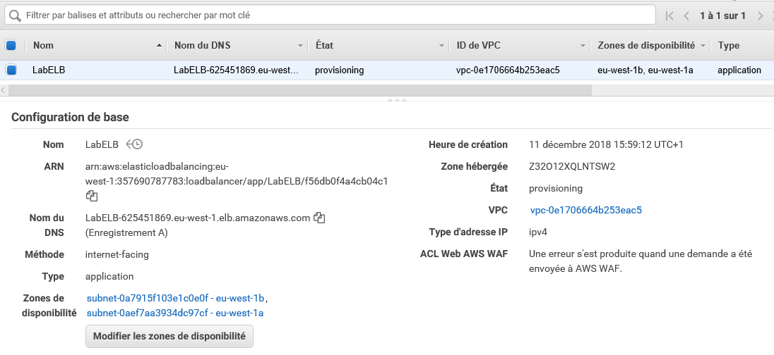

Test the ELB :-\

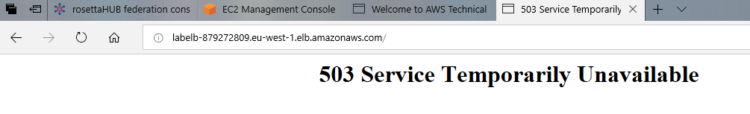

Test the EC2

EC21 OK

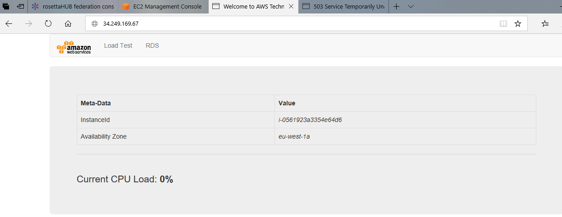

EC2 2 NOK

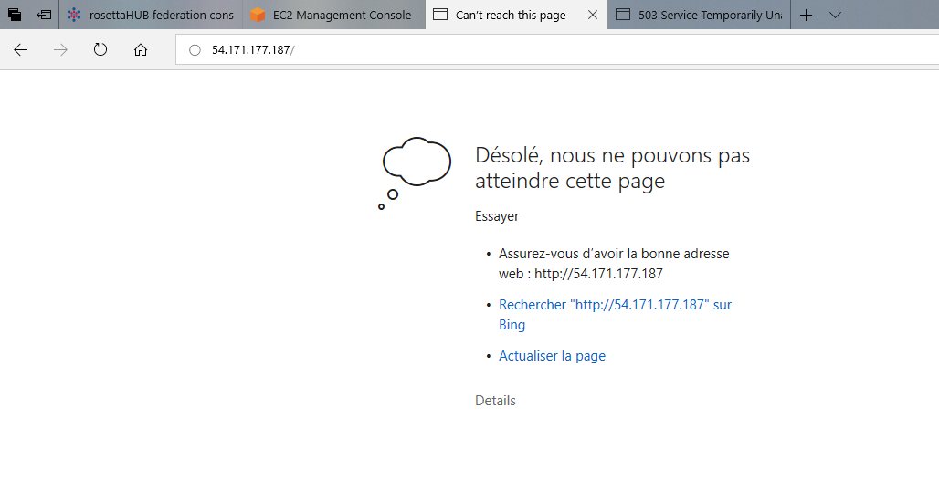

NB the ping and putty access work